SUBCOURSE EDITION
AV0992 8

U.S. ARMY AVIATION CENTER

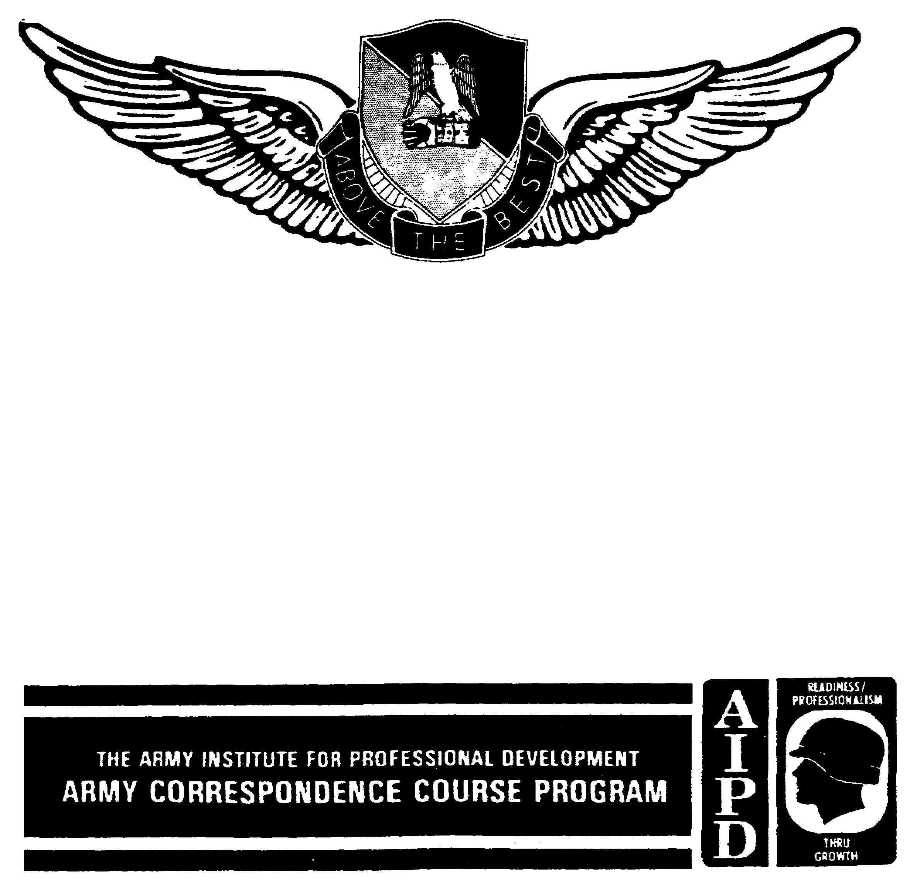

EN ROUTE CONTROL PROCEDURES

THIS SUBCOURSE HAS BEEN REVIEWED FOR
OPERATIONS SECURITY CONSIDERATIONS.

EN ROUTE CONTROL PROCEDURES

Subcourse Number AV0992

EDITION 8

US Army Aviation Center
Fort Rucker, AL 36362-5255

Credit Hours: 1

Edition Date: September 1988

SUBCOURSE OVERVIEW

This subcourse is designed to provide methods and procedures for en route air traffic control.

There is one prerequisite that must be met before you begin studying the material in this subcourse:

AV 0991, En Route Control Procedures

This subcourse reflects the doctrine that was current at the time the subcourse was prepared. In your own work situation, always refer to the latest publications.

The words "he," "him," "his," and "men," when used in this publication, represent both the masculine and feminine genders unless otherwise stated.

TERMINAL LEARNING OBJECTIVE

TASK: Describe the methods and procedures used to control en route air traffic.

CONDITIONS: You will be given extracts from Federal Aviation Administration (FAA) Handbook (FAAH) 7110.65.

i AV0992

STANDARDS: You must be able to describe the methods and procedures used to control en route air traffic according to FAAH 7110.65.

ii AV0992

TABLE OF CONTENTS

Section Page

LESSON: EN ROUTE CONTROL PROCEDURES

OVERVIEW 1

INTRODUCTION 1

EXTRACT REVIEW 3

PRACTICE EXERCISE 13

ANSWER KEY AND FEEDBACK 14

APPENDIX--PUBLICATION EXTRACTS 15

FAA Handbook 7110.65, April 1987, with Change 3

Use the above publication extract to take this subcourse. At the time this subcourse was written, this was the current publication. In your own work situation, always refer to the latest publications.

iii AV0992

LESSON

EN ROUTE CONTROL PROCEDURES

Task: NA

OVERVIEW

TASK DESCRIPTION

In this lesson you will learn to use methods and procedures to control en route air traffic.

LEARNING OBJECTIVE

ACTIONS: Describe the methods and procedures used to control en route air traffic.

CONDITIONS: You will be given extracts from Federal Aviation Administration Handbook (FAAH) 7110.65.

STANDARDS: You must describe the methods and procedures used to control en route air traffic according to FAAH 7110.65.

REFERENCES: The material in this lesson was derived from the following publication:

FAAH 7110.65, April 1987

INTRODUCTION

This lesson covers instrument flight rule (IFR) flight direction assignment, altimeter setting, and en route separation minima. A controller must be able to recognize and apply the rules applicable to the assignment of proper altitudes for flight direction, the issuance of current altimeter settings in a timely manner, and minimum separation requirements when applying lateral, vertical, or longitudinal separation.

1 AV0992

TURN TO THE APPENDIX AND STUDY THE EXTRACT. WHEN YOU HAVE COMPLETED STUDYING THE EXTRACT, BEGIN THE EXTRACT REVIEW ON THE NEXT PAGE.

WRITE YOUR RESPONSES TO THE QUESTIONS OR STATEMENTS ON EACH RIGHT-HAND (ODD-NUMBERED) PAGE BEFORE CHECKING YOUR RESPONSES WITH THE ANSWERS ON THE FOLLOWING LEFT-HAND (EVEN-NUMBERED) PAGE. THEN CONTINUE WITH THE NEXT PAGE OF QUESTIONS.

2 AV0992

EXTRACT REVIEW

1. The controller shall issue the current altimeter setting to
an en route aircraft __________________________ while operating in
his area of jurisdiction.

2. Two aircraft are on the same course, and both pilots are in
direct radio communication with each other. If they concur, you
may authorize the following aircraft to maintain longitudinal
separation of _____________ from the preceding aircraft or
____________ if they are using distance measuring equipment (DME).

3. Aircraft may be cleared to hold over different fixes at the
same altitude if the _____________________________________________
______________ .

4. Aircraft may be cleared to proceed to and report over or hold
at different geographical locations determined visually or by
navigational aids (NAVAIDs) ______________________________________ .

5. The minimum vertical separation required for aircraft
between flight level (FL) 290 and FL600 is _______________ .

3 AV0992

1. at least one time (FAAH 7110.65, paragraph 2-111c(1))

2. 10 minutes, 20 miles (FAAH 7110.65, paragraph 6-33)

3. holding pattern airspace does not overlap (FAAH 7110.65,
paragraph 6-40c)

4. if assigned an altitude below 18,000 feet (FAAH 7110.65,
paragraph 6-40b)

5. 2,000 feet (FAAH 7110.65, paragraph 6-51b)

4 AV0992

REQUIREMENT: Refer to Figure 1-1 when completing items 6 through 9.

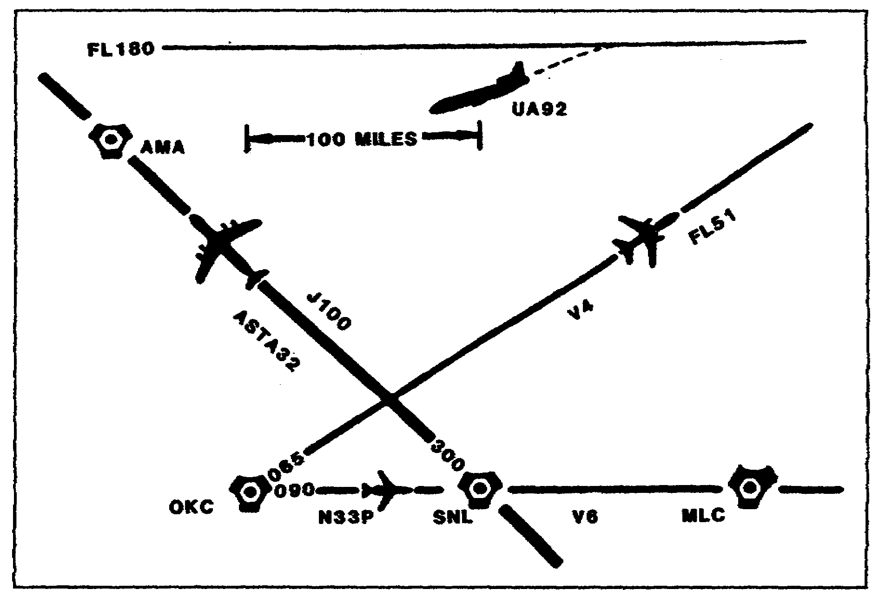

Figure 1-1. IFR Flight Direction, Assignment, and Altimeter
Setting.

6. UA92, en route MLC V6 OKC, has been cleared to descend to
120 and has reported leaving FL180. UA92 should be issued the
altimeter setting for _____ .

7. An appropriate altitude for ASTA32, en route SNL-J100 AMA,
would be an odd cardinal flight level at intervals of _________
feet beginning at FL310.

8. An appropriate altitude for N3PP, en route OKC V6 MLC, would
be any altitude if operating below ________________________________
__________ .

9. FL51, en route OKC V4, is climbing to an assigned altitude
of FL190 and has requested a new altitude assignment of 160. You
may approve this altitude if prior approval is obtained from_____
_______________________________ or __________ and _____________ .

5 AV0992

6. SNL (FAAH 7110.65, paragraph 2-111e)

7. 4,000 (FAAH 7110.65, paragraph 4-40, Table)

8. 3,000 feet above ground level (Same as 7.)

9. all affected positions, sectors, facilities (Same as 6.)

6 AV0992

REQUIREMENT: Refer to Figure 1-2 when completing items 10 through 13.

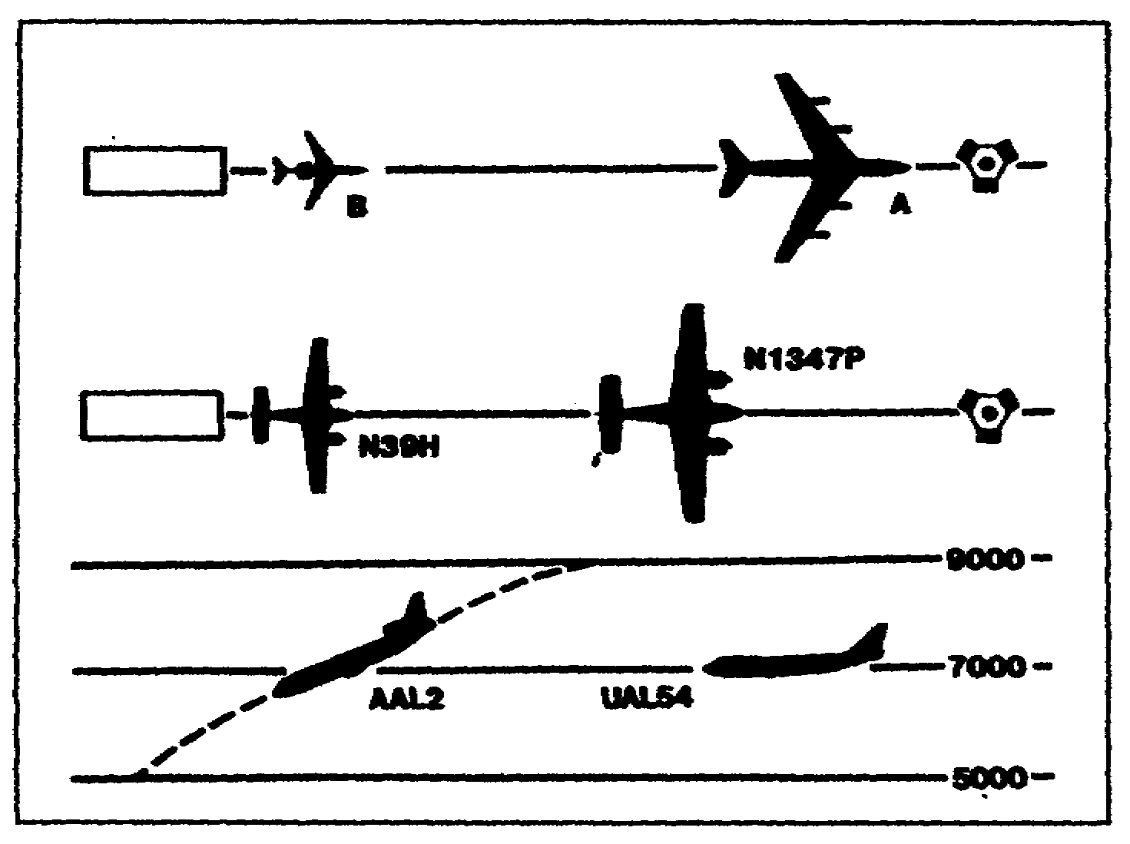

Figure 1-2. Longitudinal Separation.

10. N39H, C310/T, TAS 165, filed OKC V4 TUL, requests takeoff
clearance at 13:05 Coordination Universal Time (UTC). N1347P,
BE90/A, TAS 210, filed via the same routing, and departed at
13:02 UTC. Minimum usable longitudinal separation between these
two aircraft is ___________________ .

11 . Aircraft A, a B707/A, TAS 455, has departed OKC en route V6
HOT. Aircraft B, a C500/A, TAS 430, same routing, is ready for
departure. Both aircraft are using DME. The minimum usable
longitudinal separation between Aircraft A and Aircraft B is
__________ .

12. AAL2 and UAL54 are en route ATL to DFW. Both aircraft are
using DME. AAL2 has requested descent to 50. When AAL2 passes
through the altitude of UAL54, the minimum usable longitudinal
separation between these aircraft is __________ .

13. Aircraft B is using DME. Aircraft A is not DME equipped.
Aircraft B is deriving distance information from the same NAVAID
that Aircraft A has reported passing; Aircraft A is within 10
minutes of the NAVAID. Minimum usable separation between these
aircraft is ___________ .

7 AV0992

10. three minutes (FAAH 7110.65, paragraph 6-31a)

11. 10 miles (FAAH 7110.65, paragraph 6-31b)

12. 10 miles (FAAH 7110.65, paragraph 6-31c)

13. 30 miles (FAAH 7110.65, paragraph 6-31e)

8 AV0992

REQUIREMENT: Refer to Figure 1-3 when completing items 14 through 16.

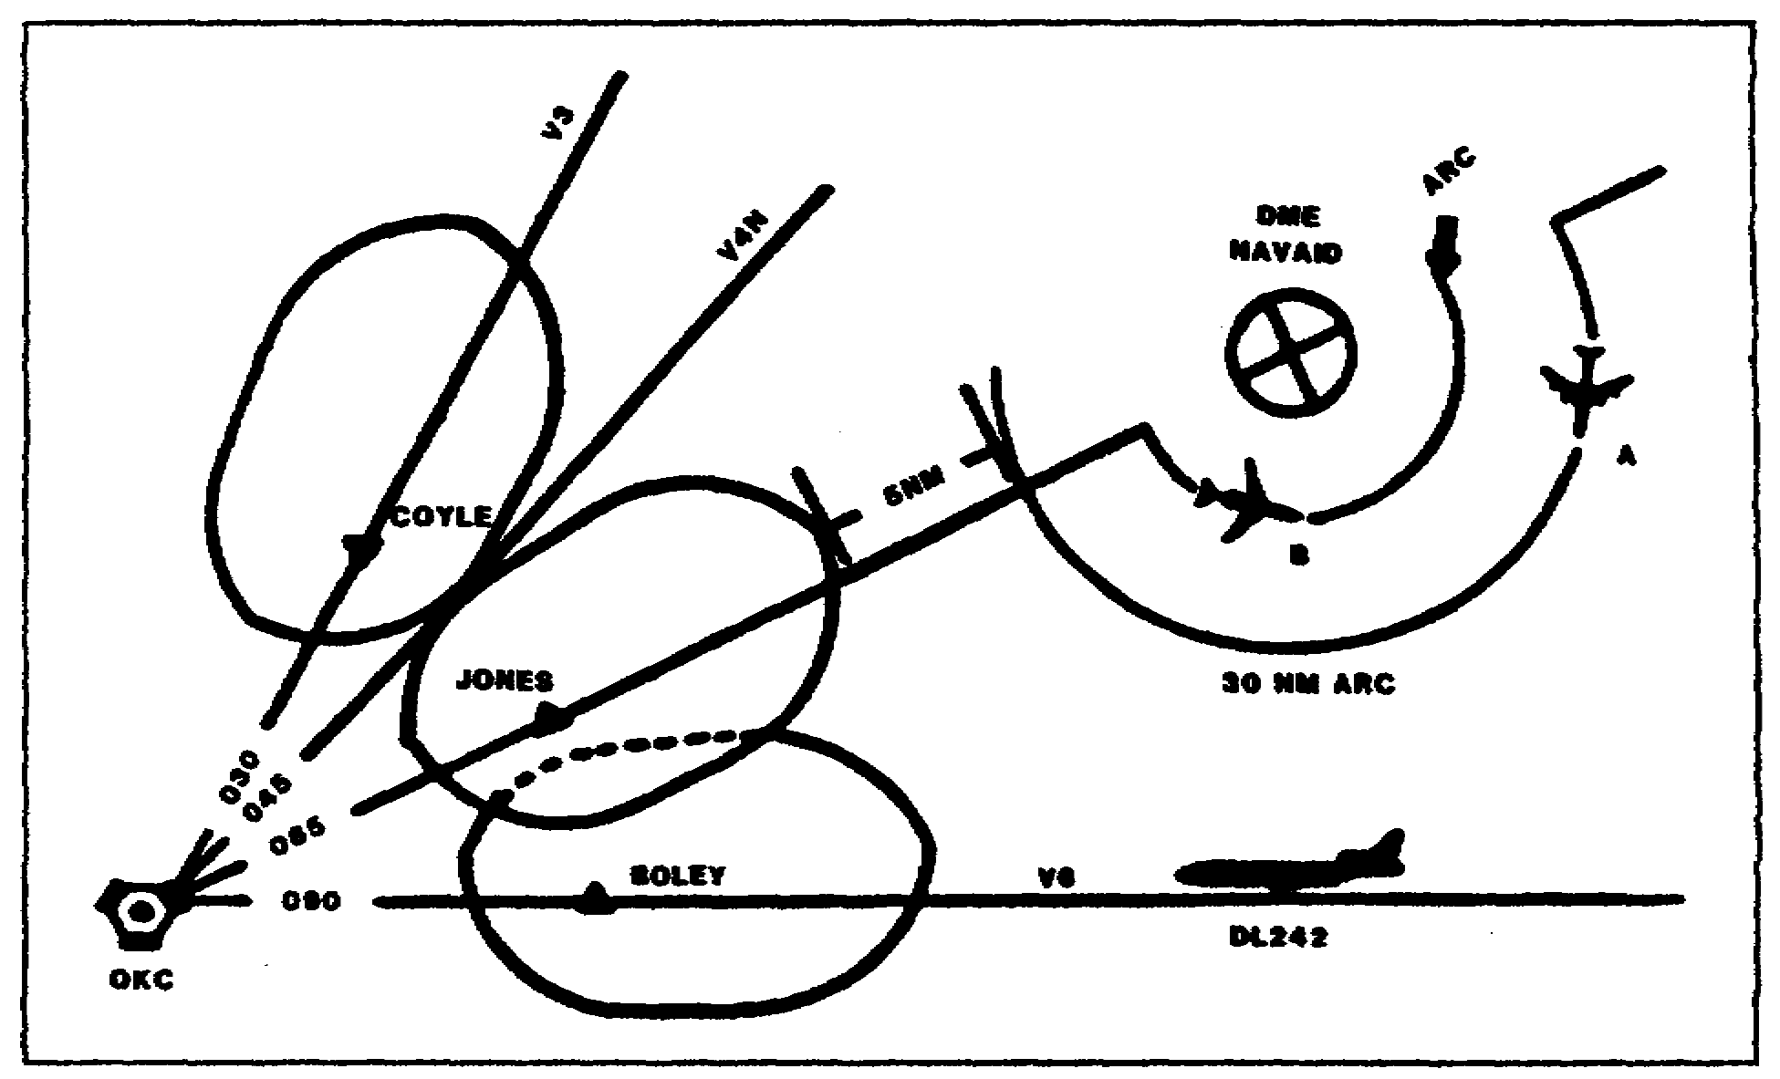

Figure 1-3. Lateral Separation.

14. Simultaneous holding may NOT be accomplished at _____________
__________________ .

15. Minimum lateral DME separation between Aircraft A and
Aircraft B is _______________ .

16. DL242, en route V6 OKC, is level at 60 and is 40 miles east
of his destination. Minimum airspace to be protected between the
centerline of V6 and the 30 nautical mile DME arc with Aircraft B
at 60 is __________ .

9 AV0992

14. Boley and Jones (FAAH 7110.65, paragraph 6-40c)

15. 10 miles (FAAH 7110.65, paragraph 6-42a(11) and
illustration)

16. 9 miles (FAAH 7110.65, paragraph 6-42a(1))

10 AV0992

REQUIREMENT: Refer to Figure 1-4 when completing items 17 through 20.

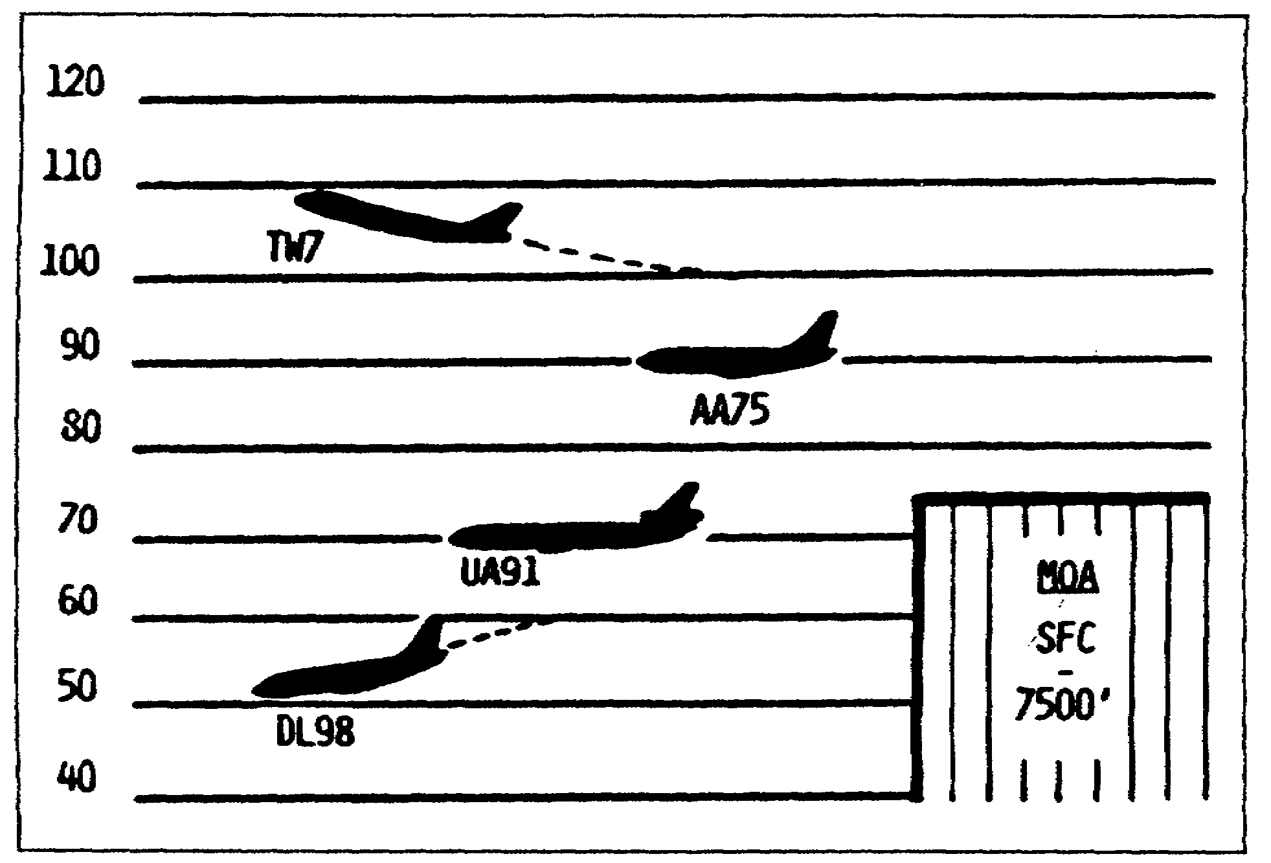

Figure 1-4. Vertical Separation.

17. TW7 has been cleared to climb to 120 and has reported
leaving 100. AA75 has requested to climb to 100. Severe
turbulence has been reported between 90 and 140. When may AA75
be assigned 100? _____________________________________________ .

18. AA75 is west bound en route V6 MLC to OKC. The lowest
altitude AA75 may be assigned to cross the depicted military
operations area is ________________ .

19. A _________ clearance authorizes DL98 to descend to minimum
IFR altitude, climb or descend within assigned altitude block at
the pilot's discretion, and proceed to and make an approach at
the destination airport.

20. DL98, cleared to cruise 40, has reported leaving 60. When
may UA91 be assigned 60? _______________________________________ .

11 AV0992

17. when TW7 reports leaving 110 (FAAH 7110.65, paragraph 6-52)

18. 8,000 feet (FAAH 7110.65, paragraph 4-40 Table and
paragraph 8-41a)

19. cruise (FAAH 7110.65, paragraph 6-52c(2) Note and Appendix
A, CRUISE)

20. when DL98 reports leaving 50 (FAAH 7110.65, paragraph 6-52)

12 AV0992

LESSON

PRACTICE EXERCISE

The following items will test your grasp of the material covered in this lesson. There is only one correct answer for each item.

When you have completed the exercise, check your answers with the answer key that follows. If you answer any item incorrectly, study again that part of the lesson which contains the portion involved.

1. How often is an altimeter setting issued to en route
aircraft operating in your area of jurisdiction?

A. as needed
B. on request
C. at least once
D. never

2. Aircraft operating at altitudes below 3,000 feet above the
surface and not within an altitude reservation may be assigned
which of the three altitudes listed?

A. any
B. odd cardinal
C. even cardinal

3. Which statement represents longitudinal separation?

A. Assign aircraft different altitudes.
B. Clear aircraft to hold over different fixes.
C. Clear aircraft on different airways or routes.
D. Clear aircraft to arrive at a fix at different times.

4. Which statement represents lateral separation?

A. Assign aircraft different altitudes.
B. Clear aircraft to hold over different fixes.
C. Clear aircraft on different airways or routes.
D. Clear aircraft to arrive at a fix at different times.

5. Which statement represents vertical separation?

A. Assign aircraft different altitudes.
B. Clear aircraft to hold over different fixes.
C. Clear aircraft on different airways or routes.
D. Clear aircraft to arrive at a fix at different times.

13 AV0992

LESSON

PRACTICE EXERCISE

ANSWER KEY AND FEEDBACK

Item Correct Answer and Feedback

1. C. at least once

According to FAAH 7110.65, it is a requirement to issue
the altimeter setting at least once. (FAAH 7110.65,
paragraph 2-111c(1))

2. A. any

This is the standard altitude below 3,000 feet.
(FAAH 7110.65, paragraph 4-40 Table)

3. D. Clear aircraft to arrive at a fix at different times.

This is one method of longitudinal separation.
(FAAH 7110.65, paragraph 6-30a)

4. C. Clear aircraft on different airways or routes.

This is one method of lateral separation. (FAAH 7110.65,
paragraph 6-40a)

5. A. Assign aircraft different altitudes.

This is vertical separation. (FAAH 7110.65,
paragraph 6-51)

14 AV0992

